Q1: First Palindromic String
Aim
To locate the earliest string that reads identically from left to right and right to left.
Algorithm
1. Read the list of words.
2. Check each word against its reverse.
3. Return the first matching word.
4. If none matches, return an empty string.
Input
words = [abc , car, ada , racecar , cool ]
Output
Ada
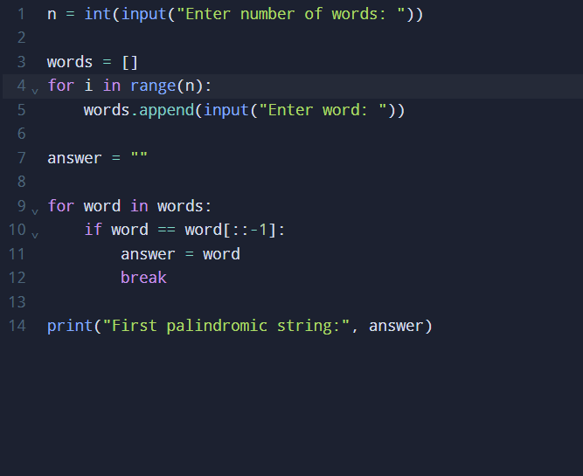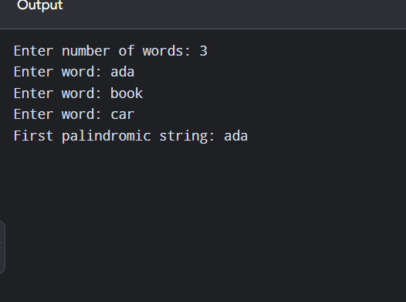

Time Complexity: O(nL)
Space Complexity: O(1)
Result
The program returns the first palindromic word, "ada".

Q2: Count Common Values in Two Arrays
Aim
To count array positions whose values also occur in the other array.
Algorithm
1. Convert each array to a set for membership checks.
2. Count nums1 elements present in set(nums2).
3. Count nums2 elements present in set(nums1).
4. Return both counts.
Input
nums1 = [2, 3, 2], nums2 = [1, 2]
Output
[2, 1]
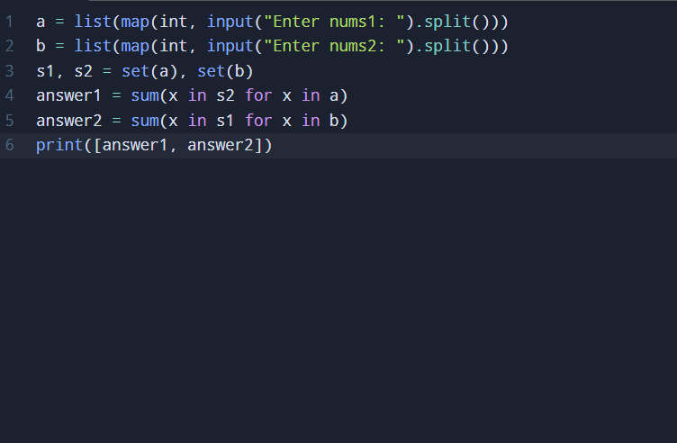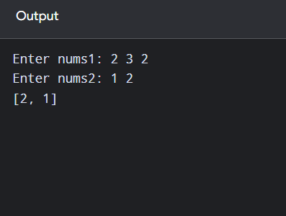
Time Complexity: O(n+m) average
Space Complexity: O(n+m)
Result
The returned counts are [2, 1].

Q3: Sum of Squared Distinct Counts of All Subarrays
Aim
To calculate the total of squared distinct-element counts for every non-empty subarray.
Algorithm
1. Start from each index i.
2. Extend the subarray one element at a time.
3. Maintain a set of distinct values.
4. Add the square of the set size to the total.
Input
nums = [1, 2, 1]
Output
15
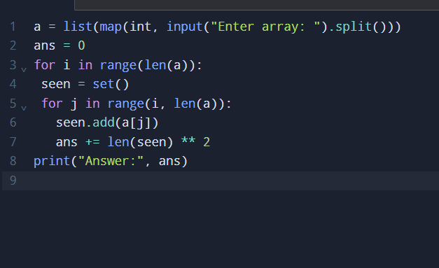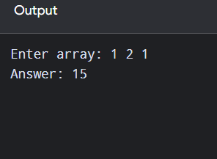
Time Complexity: O(n²)
Space Complexity: O(n)
Result
The sum of squared distinct counts is 15.

Q4: Equal-Value Index Pairs Divisible by k
Aim
To count pairs of equal values whose index product is divisible by k.
Algorithm
1. Examine every pair i, j with i < j.
2. Check nums[i] == nums[j].
3. Check (i * j) % k == 0.
4. Increase the count for every valid pair.
Input
nums = [3, 1, 2, 2, 2, 1, 3], k = 2
Output
4
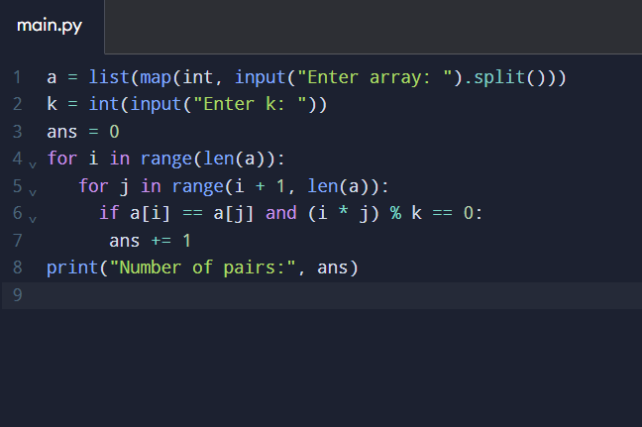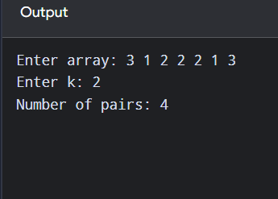
Time Complexity: O(n²)
Space Complexity: O(1)
Result
There are 4 valid index pairs.

Q5: Find the Maximum Element
Aim
To identify the largest value in a list using one scan.
Algorithm
1. If the list is empty, report that no maximum exists.
2. Set maximum to the first element.
3. Compare each remaining element with maximum.
4. Return the largest value.
Input
1 2 3 4 5
Output:
5
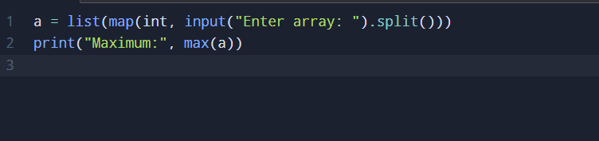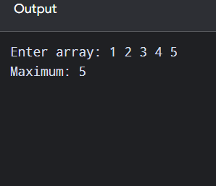
Time Complexity: O(n)
Space Complexity: O(1)
Result
The largest element is found in a single traversal.

Q6: Sort Then Find Maximum
Aim
To sort a list with an efficient built-in sorting routine and retrieve its maximum safely.
Algorithm
1. If the list is empty, return None.
DAA Python Solutions Page 4
2. Sort the list in ascending order.
3. Return the last element.
Input: 3 7 2 9
Output:[2, 3, 7, 9]
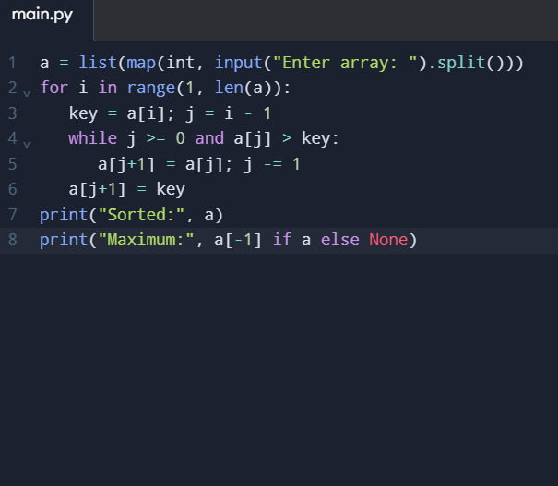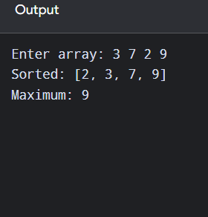
Time Complexity: O(n²)
Space Complexity: O(1)
Result
The maximum is returned correctly, including empty and single-item lists.

Q7: Create a List of Unique Elements
Aim
To remove repeated values while preserving the first occurrence order.
Algorithm
1. Create an empty set and result list.
2. Visit each input value.
3. If it has not appeared before, add it to the set and result.
4. Return the result list.
Input: 3 7 3 5 2 5
Output: [3, 7, 5, 2]
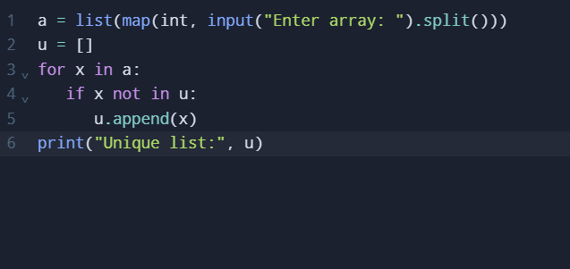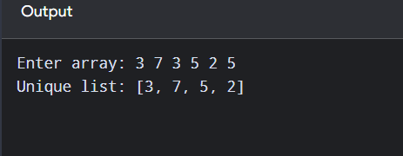
Time Complexity: O(n²)
Space Complexity: O(n)
Result
Only first occurrences are kept, in original order.

Q8: Bubble Sort
DAA Python Solutions Page 5
Aim
To arrange integer values in ascending order by repeatedly swapping adjacent out-of-order values.
Algorithm
1. Compare neighboring elements.
2. Swap if the left element is greater.
3. Repeat passes, reducing the unsorted range each time.
4. Stop when a pass makes no swaps.
Input: 5 2 9 1
Output: [1, 2, 5, 9]
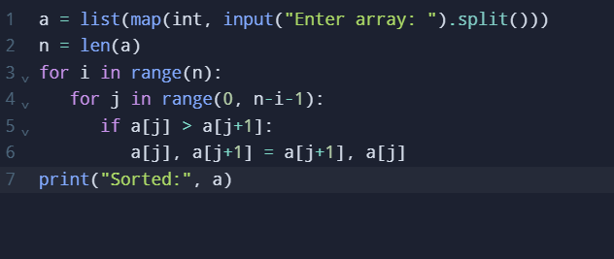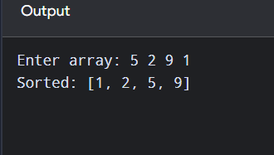
Time Complexity: O(n²)
Space Complexity: O(1)
Result
The list is sorted; early stopping improves already-sorted inputs.

Q9: Binary Search
Aim
To locate a key in a sorted array by repeatedly halving the search interval.
Algorithm
1. Set left and right boundaries.
2. Find the middle index.
3. If the middle value is the key, return its index.
4. Otherwise discard the half that cannot contain the key.
5. Return -1 if absent.
Input: 3 4 6 8 10 10
Output: 5
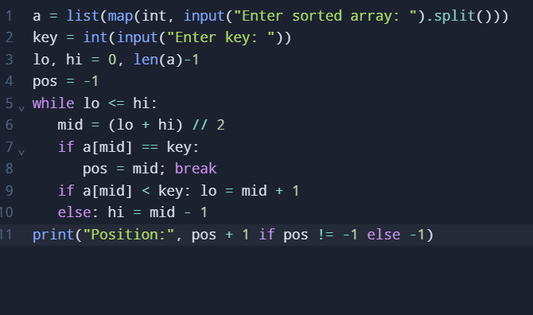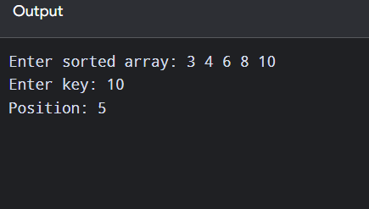
Time Complexity: O(log n)
Space Complexity: O(1)
Result
Binary search works only on a sorted array. The example array was sorted before searching.

Q10: Merge Sort Without Built-in Sorting
Aim
To sort an array in O(n log n) time using divide-and-conquer.
Algorithm
1. Divide the list into two halves.
2. Recursively sort both halves.
3. Merge the sorted halves by comparing their first remaining elements.
4. Return the merged list.
Input: 5 3 1 4 2
Output: [1, 2, 3, 4, 5]
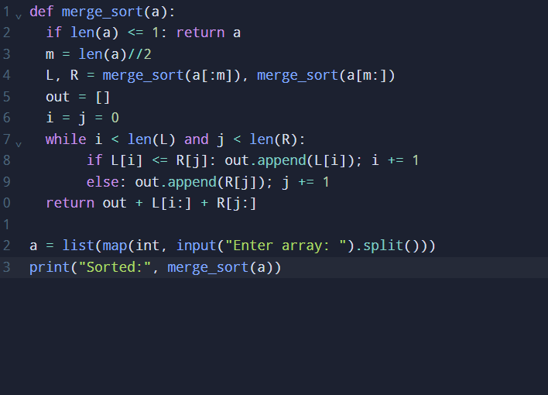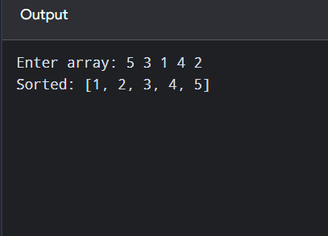
Time Complexity: O(n log n)
Space Complexity: O(n)
Result
Merge sort sorts without using a built-in sorting function.

